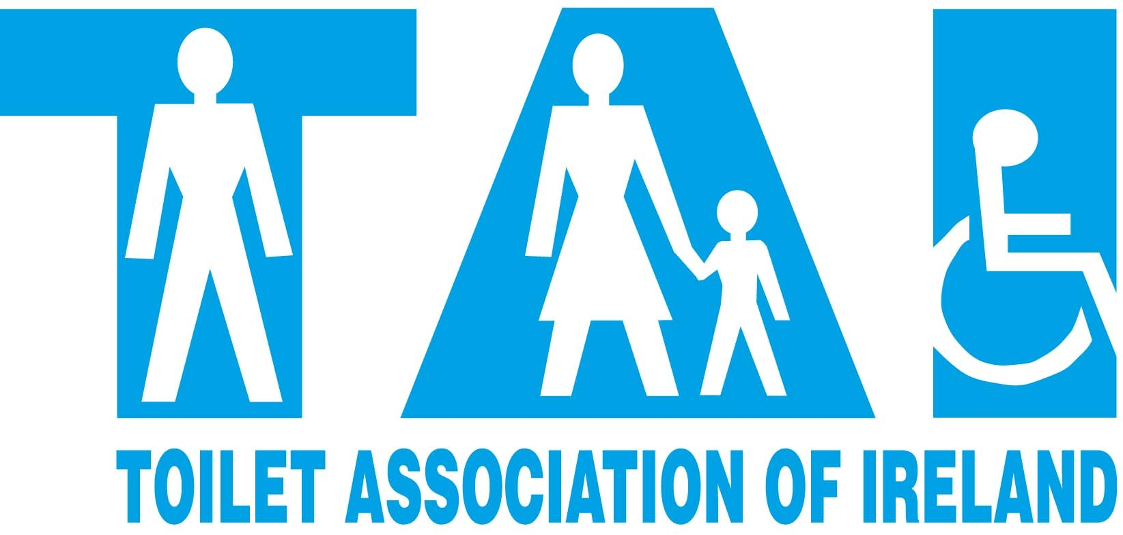
The Toilet Association of Ireland Limited
Unit 79, Enterprise House, 2 – 4 Balloo Avenue
Bangor, Co.Down Northern Ireland BT19 7QT
Tel/Fax: 02891 477 397
E-Mail enquiries@toiletsinireland.net

MEMBERSHIP AGREEMENT

MEMBERS NAME
We hereby confirm that the above named company has agreed to become a Member of the Toilet Association of Ireland for a period of twelve months.
The agreed membership fee is £ per annum and is payable on each anniversary of the date below.

In return, the TAI ( Toilet Association of Ireland ) has agreed the following:

- Membership of the Association for the duration of the Agreement
- Reduced rates for all conference delegates and exhibition spaces.
- Reduced Consultancy Fees on all works conducted by TAI
- TAI support for all your activities in Ireland.
- Promotion of your support at all possible opportunities
- Leads and referrals from enquiries received by TAI
- Inclusion of your company name in all relevant publications
- Inclusion of your company logo on the TAI Web-Site

Both parties undertake to develop an effective partnership for the duration of this agreement with the shared objective of promoting the need for more and better quality “ away from home “ toilets throughout Ireland.

Signed on behalf of Signed on behalf of

TOILET ASSOCIATION of IRELAND

SignatureSignature

NameName

PositionPosition

DateDate

